In this project, I used **Azure Active Directory (Azure AD) to enhance identity and access security** by implementing **Multi-Factor Authentication (MFA), Conditional Access, and Role-Based Access Control (RBAC)**. These security measures **reduce the risk of unauthorized access and improve compliance with enterprise security standards**.

1. We begin by creating a Azure Tenant

Creating a new Azure AD tenant

* Select the Create a Resource option in the Azure portal - Search for Azure AD which has now recently been renamed Microsoft Entra ID

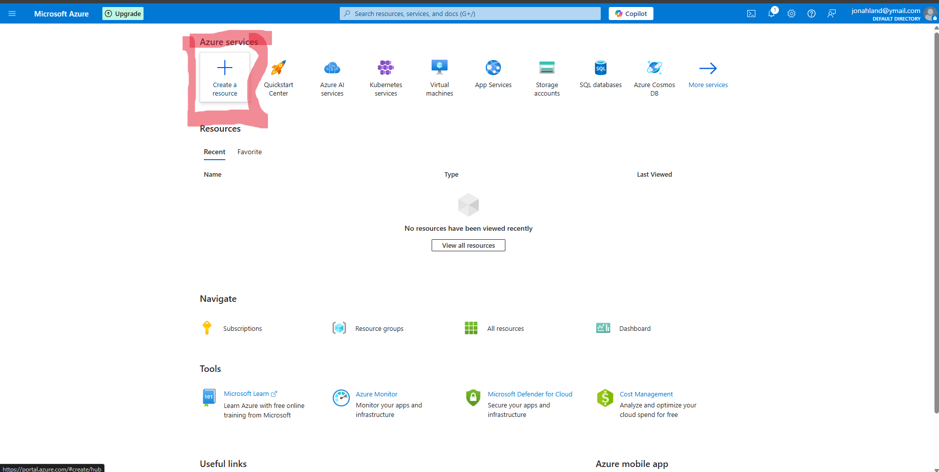

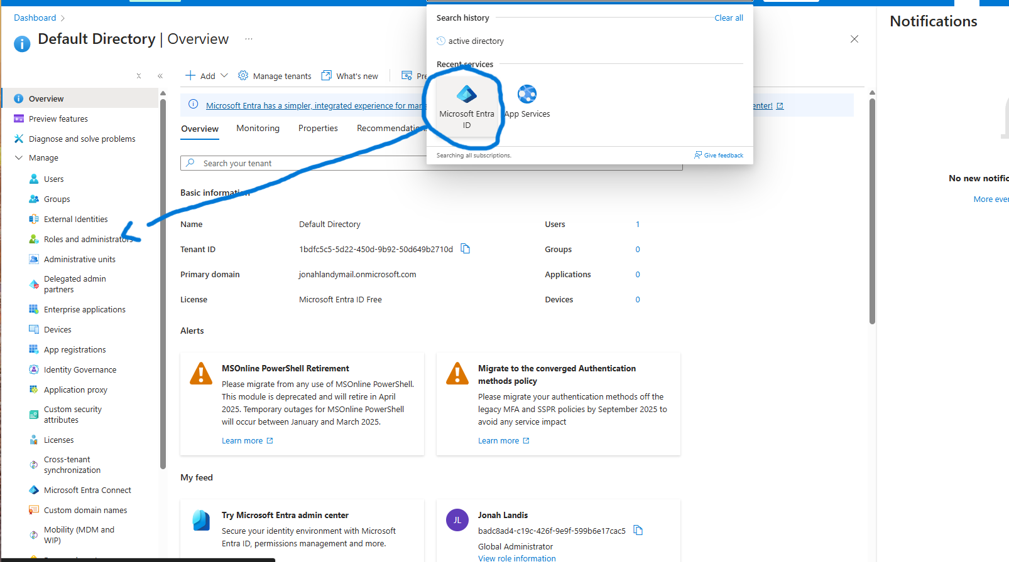

1. After adding the new tenant we will want to create a new user. You will need to be Global Administrator to manage all aspects of Azure AD

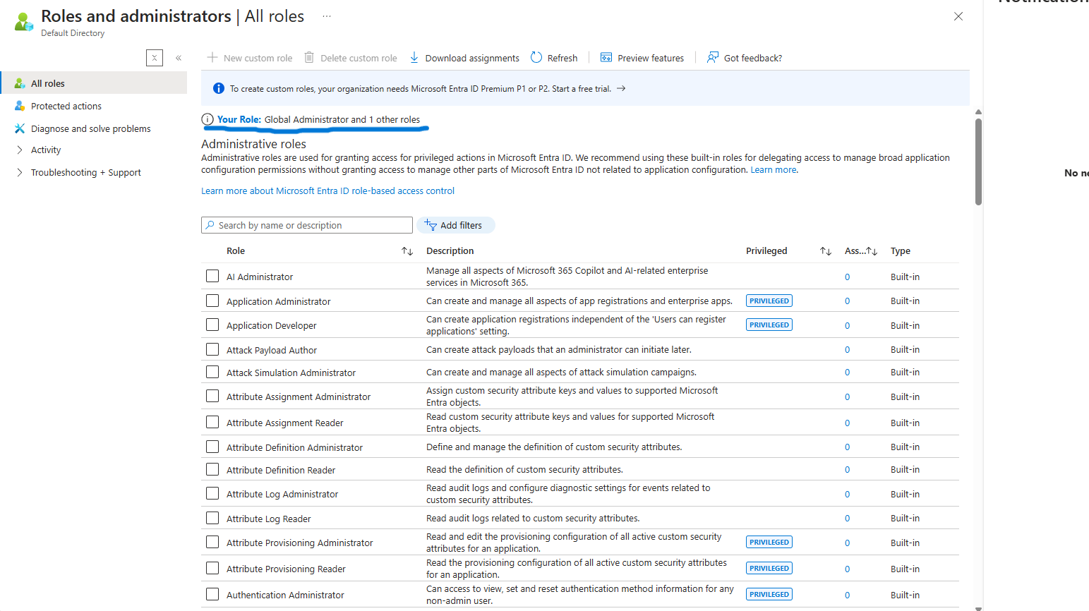

1. Under manage select “Users” and then “New Users”

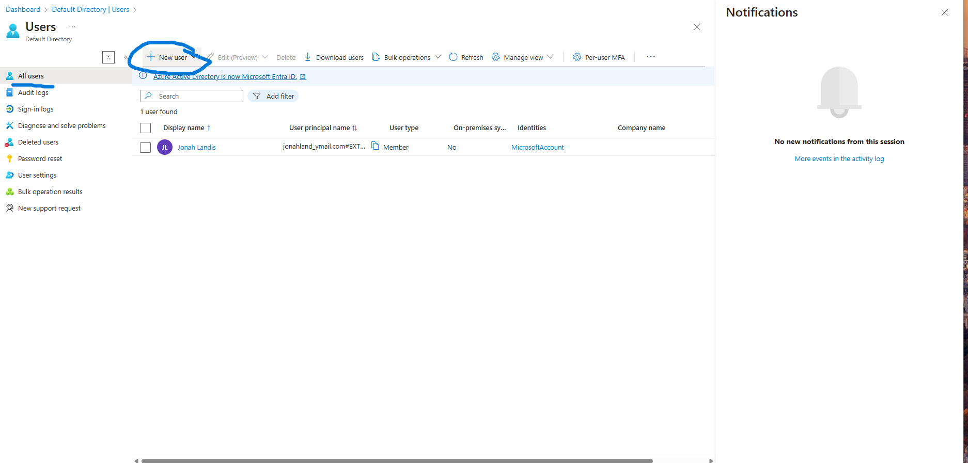

4.Now it's time to fill in user details.

* For user name , John@[jonahland@ymail.onmicrosoft.com](mailto:jonahland@ymail.onmicrosoft.com)
* For Name, Enter John
* Assign Strong password or allow Azure to create one for you
* Click create to finalize
* *Repeat steps above for other users Dave and Jeff*

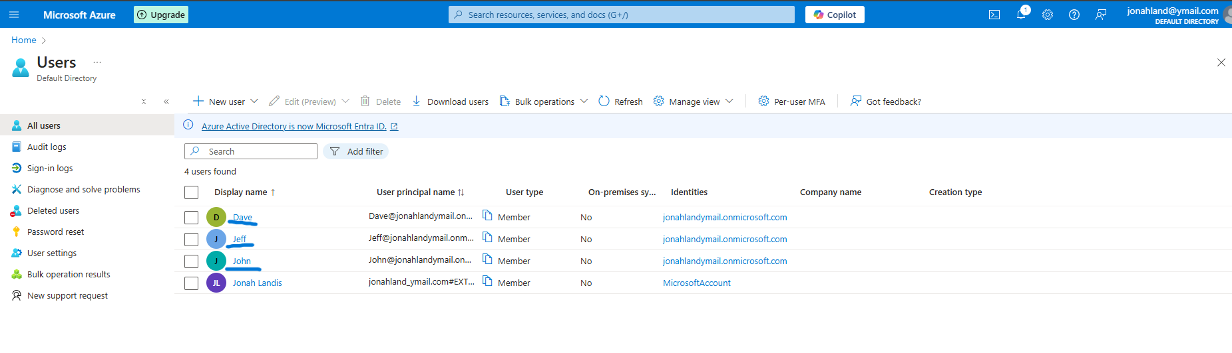

All 3 Users have been added to the Azure AD

Task 2: Create a group called Devsupport and add members.

* Navigate to **Groups** under **manage**

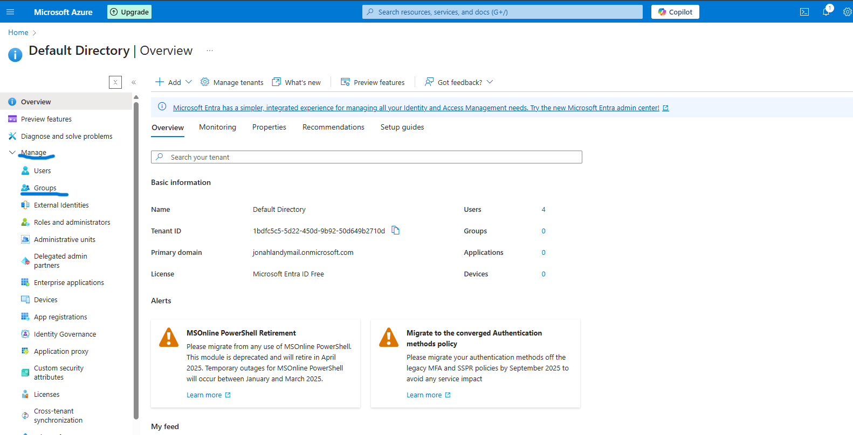

1. Select +New group

* Choose **Security** or **Microsoft 365** ( depends on your requirments)
* Name the group “Dev Support”

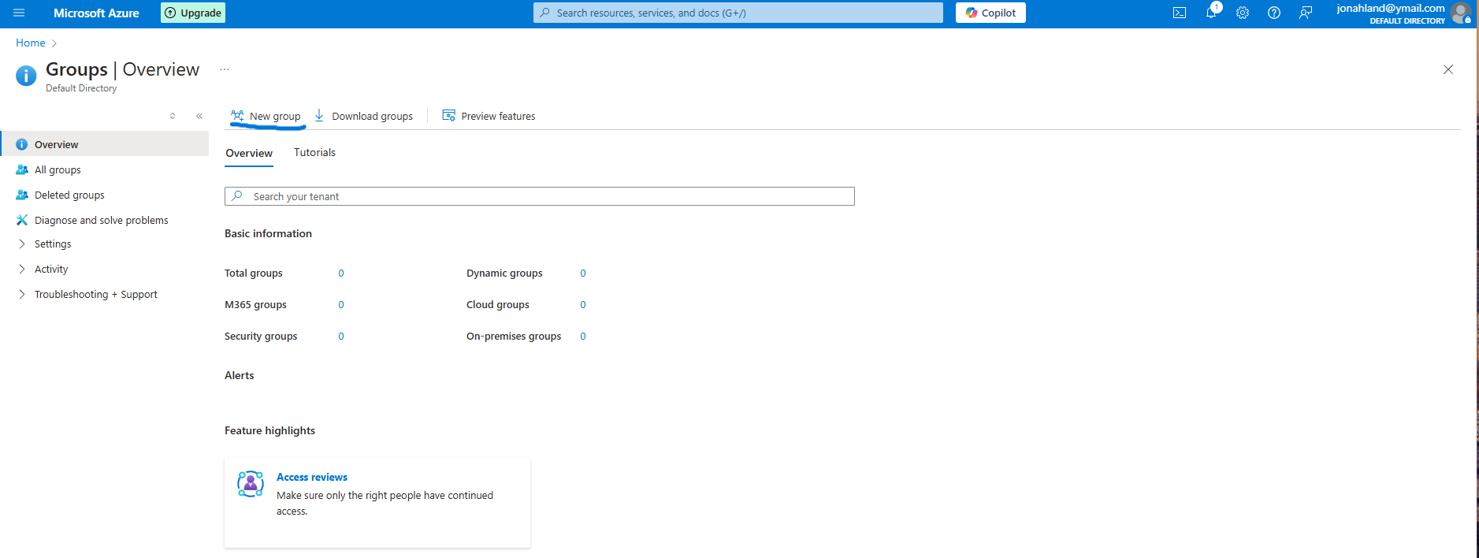

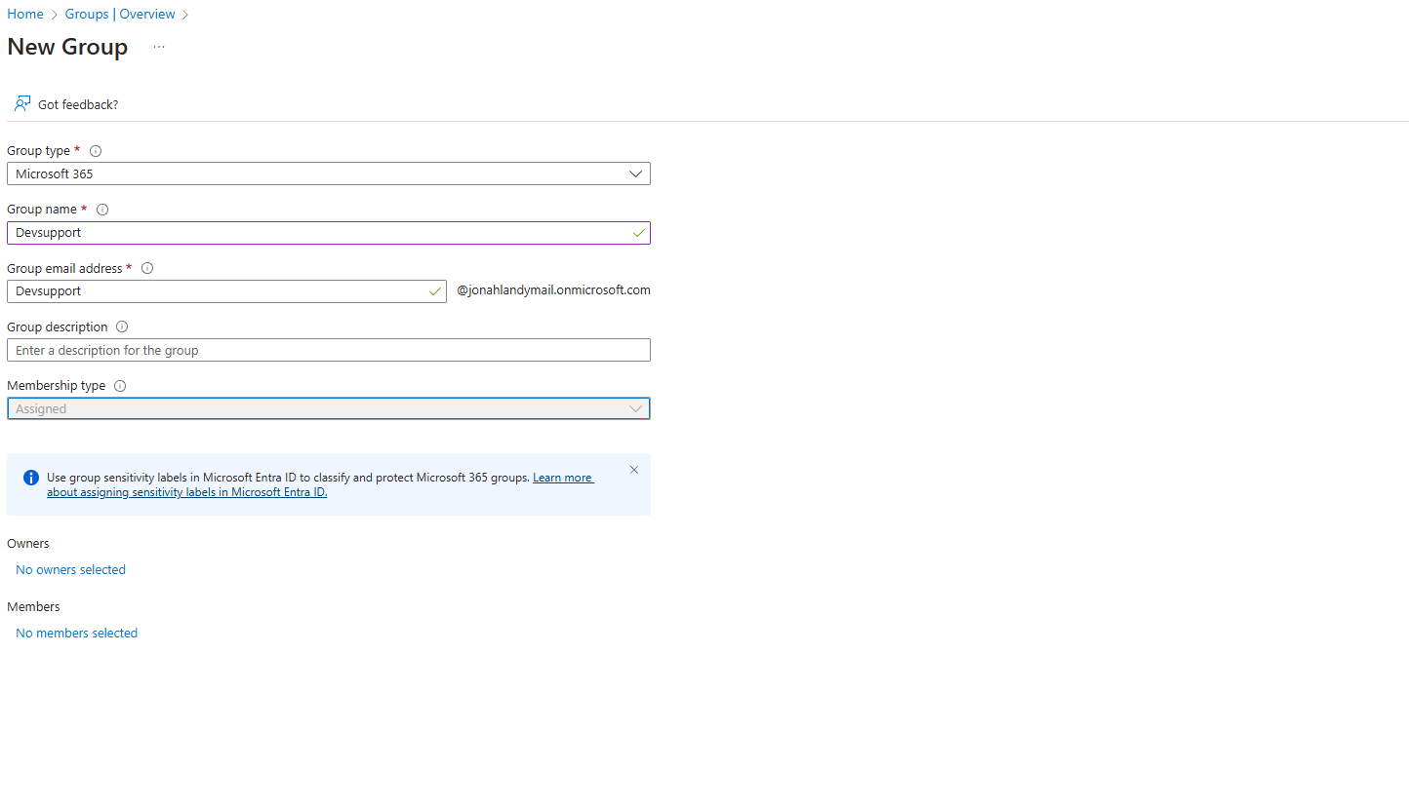

1. Now we need to add our members **John**, **Dave** and **Jeff**

* Under manage, select members and + Add members

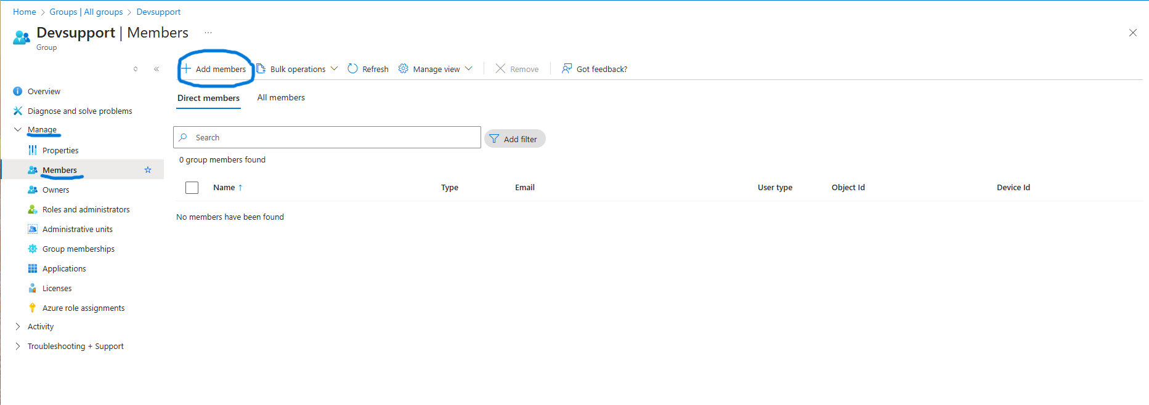

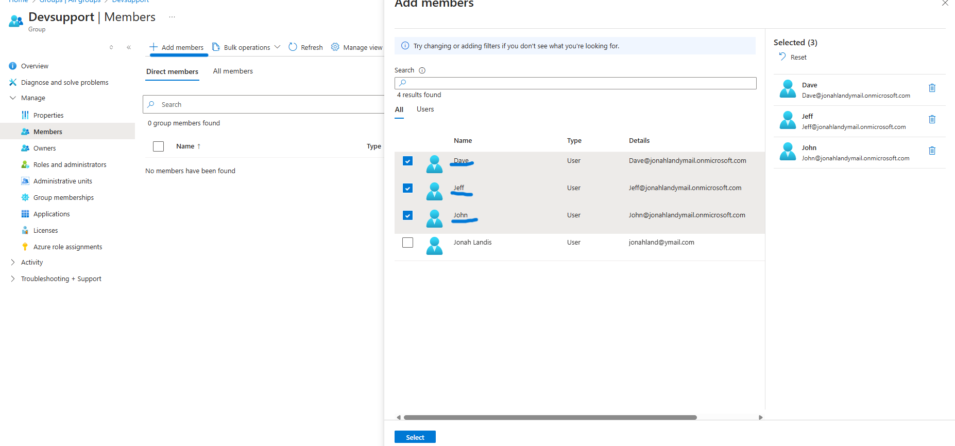

1. The Devsupport group has now been added and members have been attached.

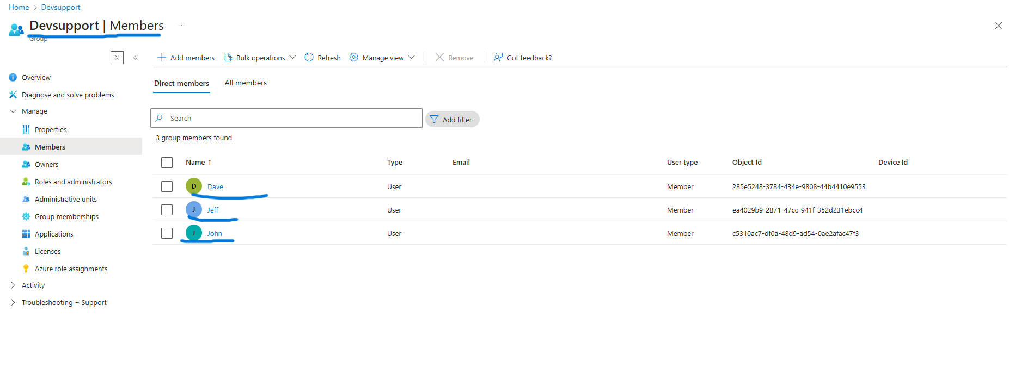

Task 3: Enable Self-service password reset

1. Under manage navigate to password reset.

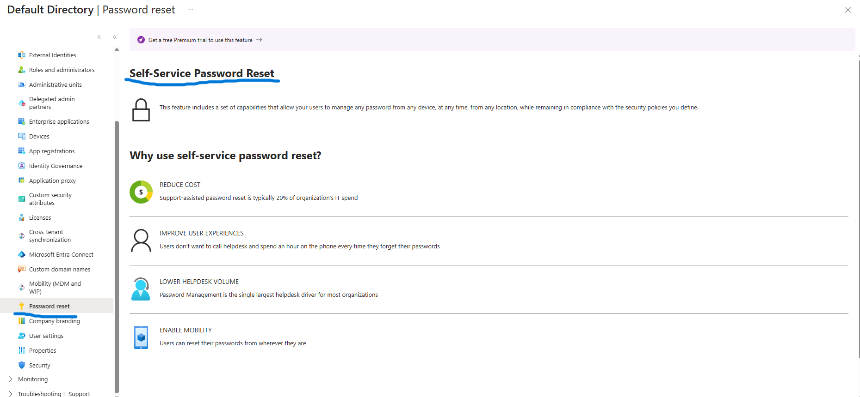

1. Select properties> Self service password reset enabled “selected”. Now select our Devsupport group.

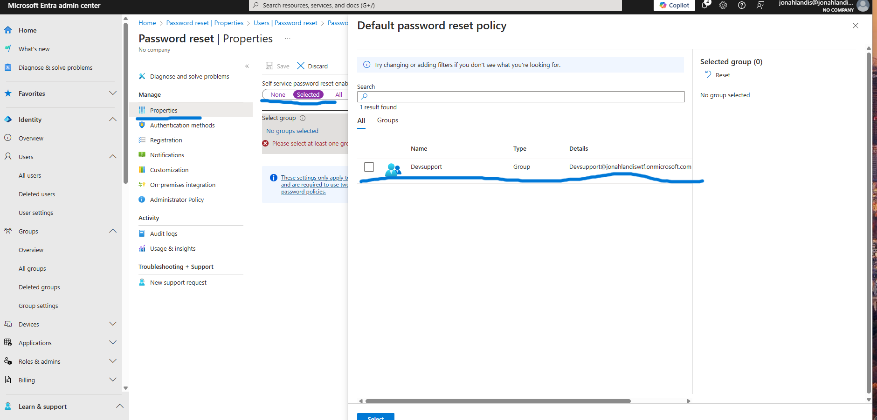

Now our group has been successfully added.

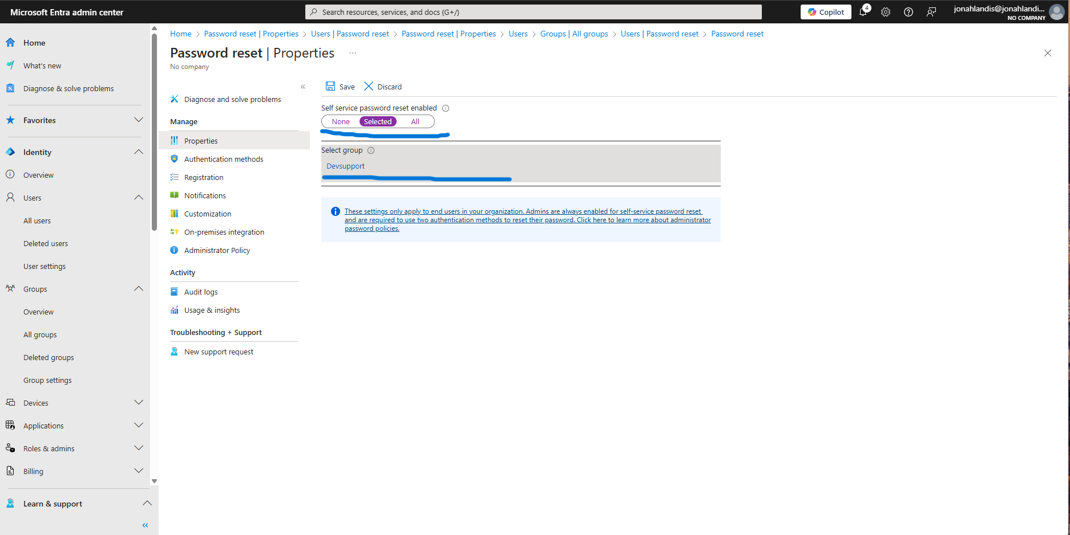

Task 4: Test self-service password reset

* We will begin by signing onto Dave's account and then navigating to security info.
* Success we are able to change Dave's password

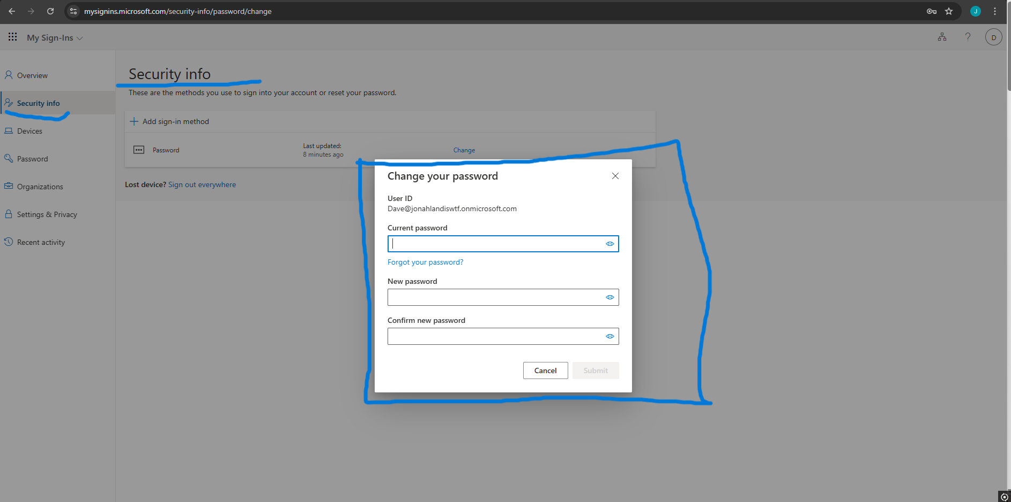

Task 5: Enable and configure multi factor authentication for a user.

* Click on **"Users"** under **Manage**.
* In the top menu, click **"Per-user MFA"**

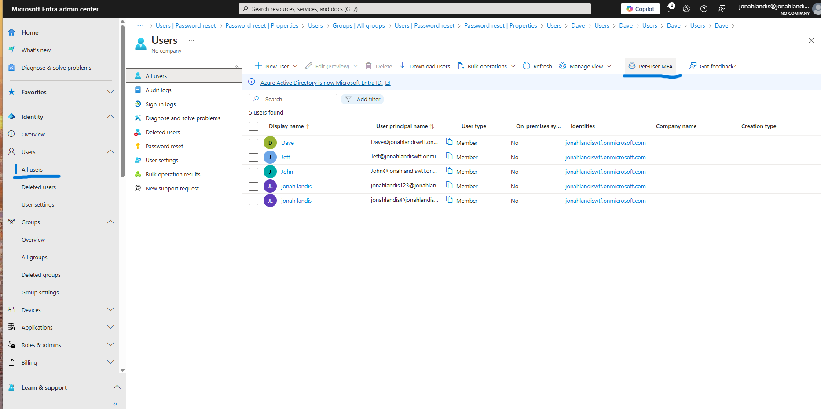

* In the **MFA settings portal**, find **John, Dave, and Jeff** in the list.
* Select each user and click **"Enable"** in the right panel.
* Confirm the **MFA activation** for each user.
* Once enabled, click **"Enforce"** to require MFA during their next login.

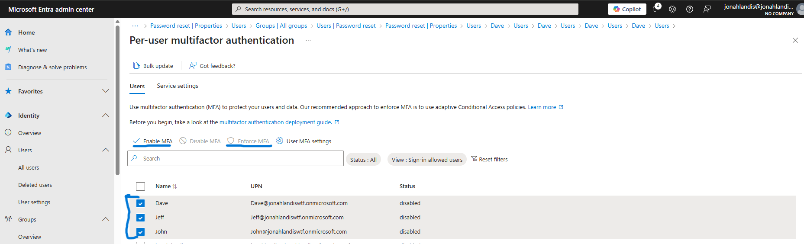

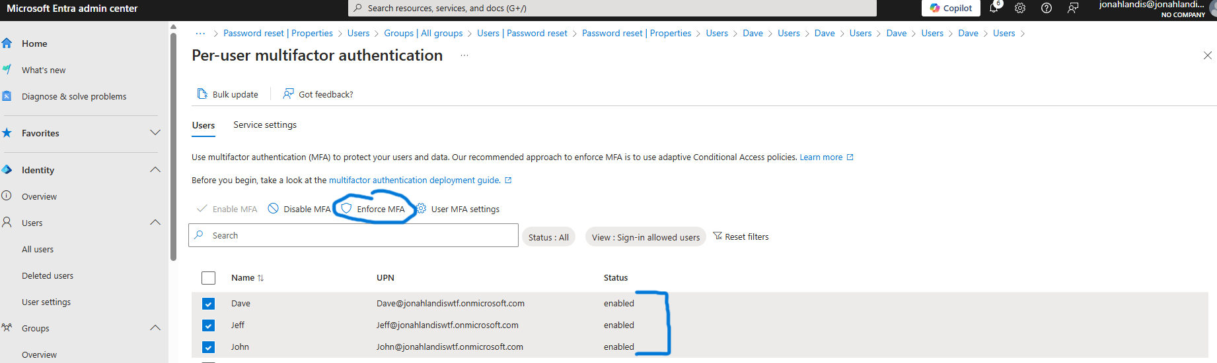

Now we can see Dave is required to download MFA before being able to sign back in.

